Athllon Park – Blue layout v1.0
This blue layout is a challenge! It’s designed to be harder than Eddison Blue, with more technicality than Weston Gold, but not the distance. Expected par is estimated to be roughly a 920 rated.
There is a red 9-hole loop available on uDisc if you are after a shorter experience.

Hole 1 – Par 3 (116m)
Rules:
- Footpaths and road play as out of bounds
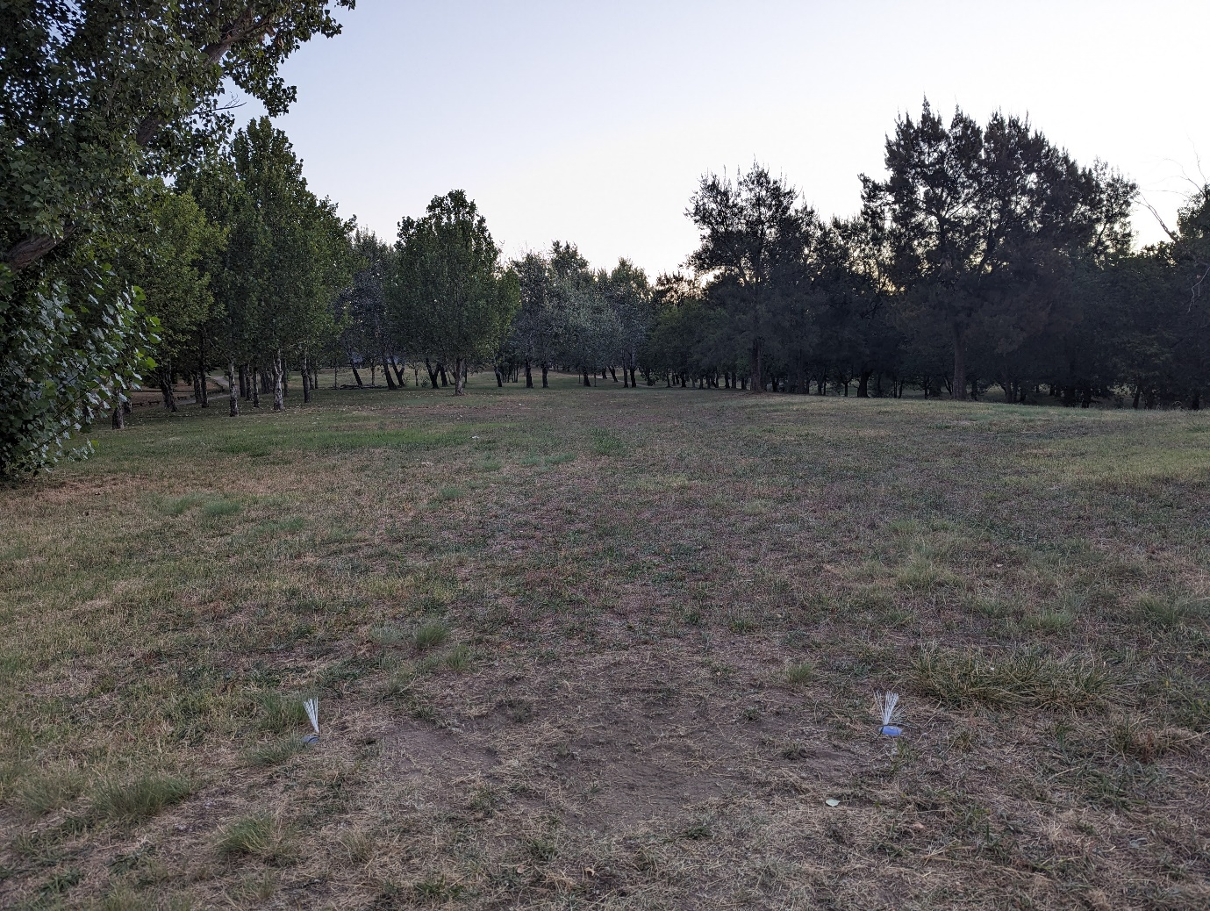

Hole 2 – Par 3 (84m)
Rules:
- Footpaths and road play as out of bounds
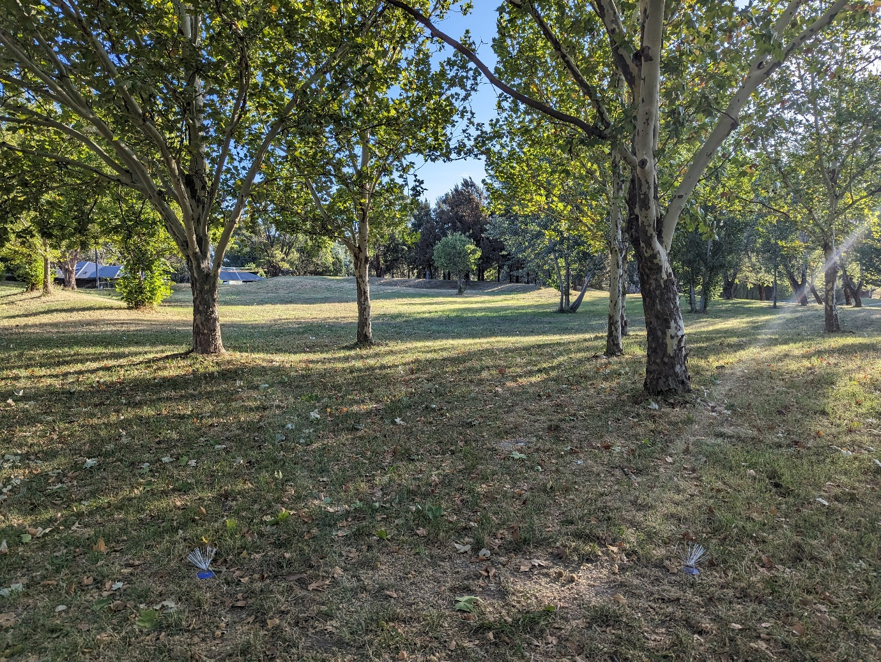

Hole 3 – Par 3 (98m)
Rules:
- Footpaths and road play as out of bounds
- Mandatory left of the tree indicated below.
- Drop zone from white markers next to the tree
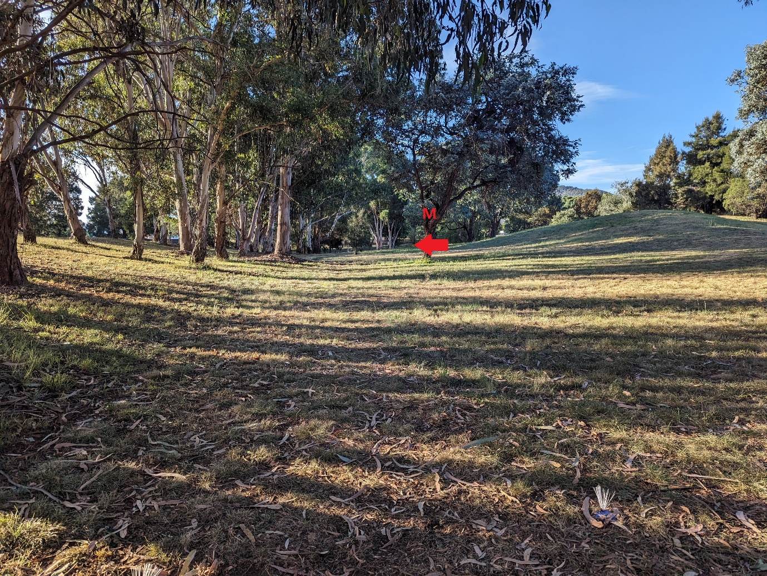

Hole 4 – Par 4 (182m)
Rules:
- Footpaths on the right play as out of bounds (but should not come into play)
- Water is out of bounds
- Be mindful of players on Holes 5 & 6 in the trees
- Basket is tucked on the peninsula to the left
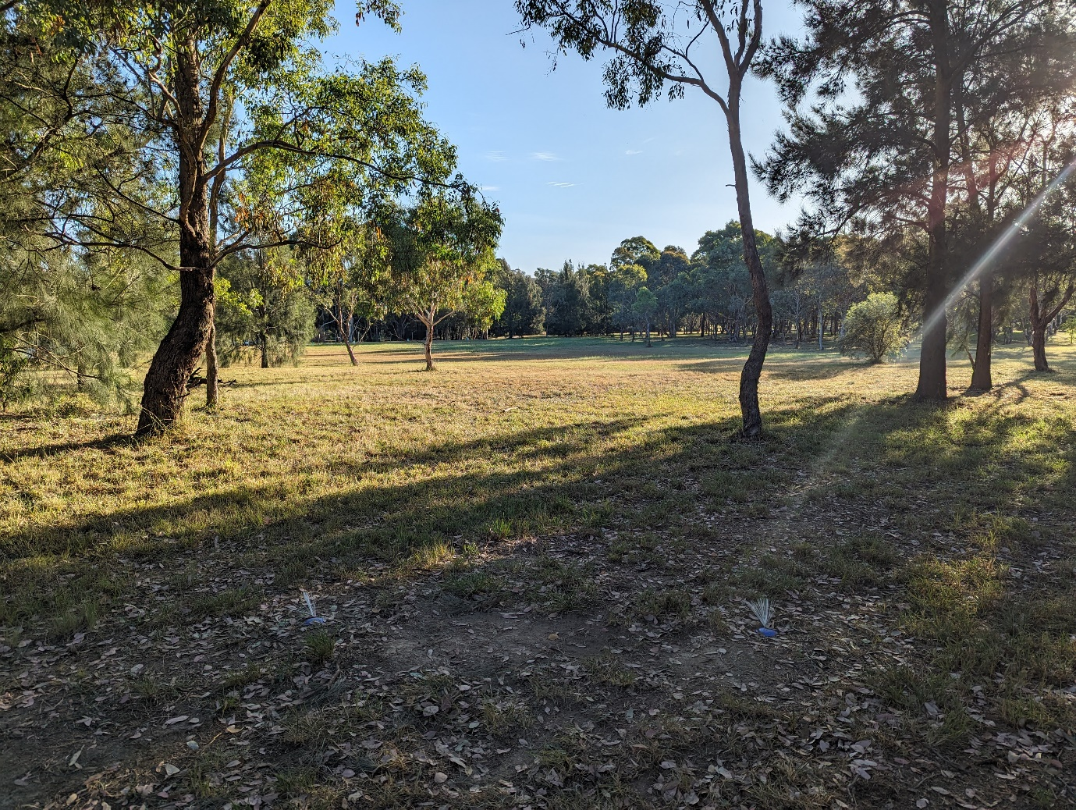

Hole 5 – Par 3 (89m)
Rules:
- Footpaths on the left play as out of bounds (but should not come into play)
- Be mindful of players on Holes 4 & 6 in the trees
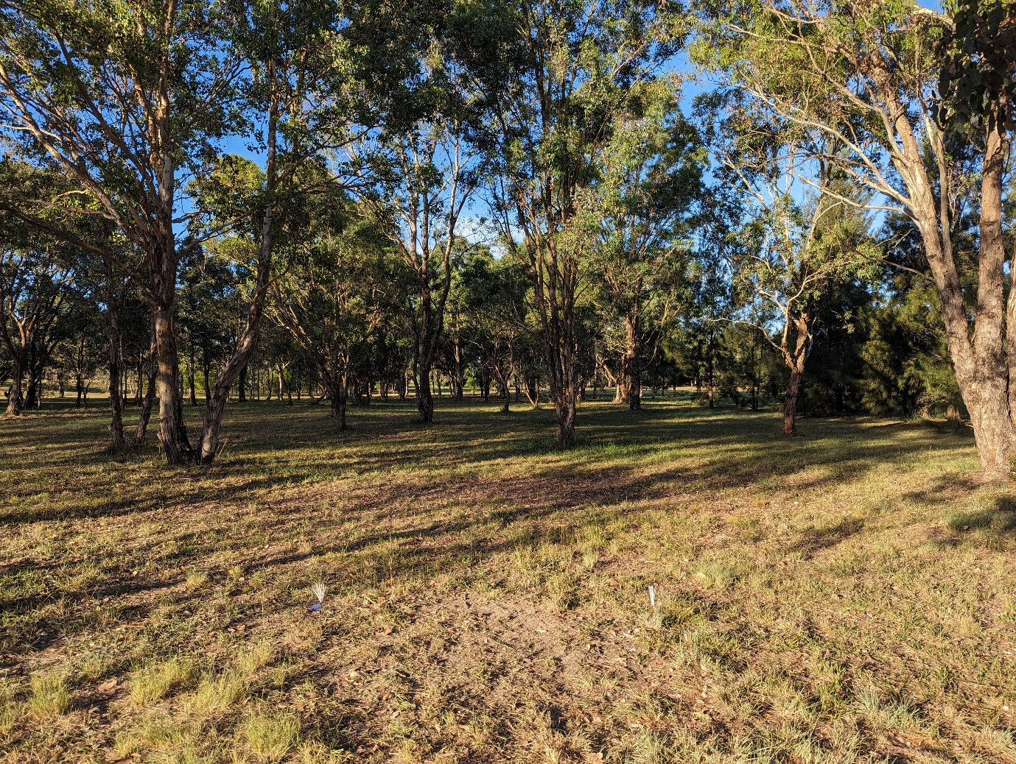

Hole 6 – Par 3 (86m)
Rules:
- Footpaths on the right play as out of bounds (but should not come into play)
- Concrete deep of the pin plays as out of bounds
- Water plays as out of bounds
- Be mindful of players on Holes 4 & 5 in the trees
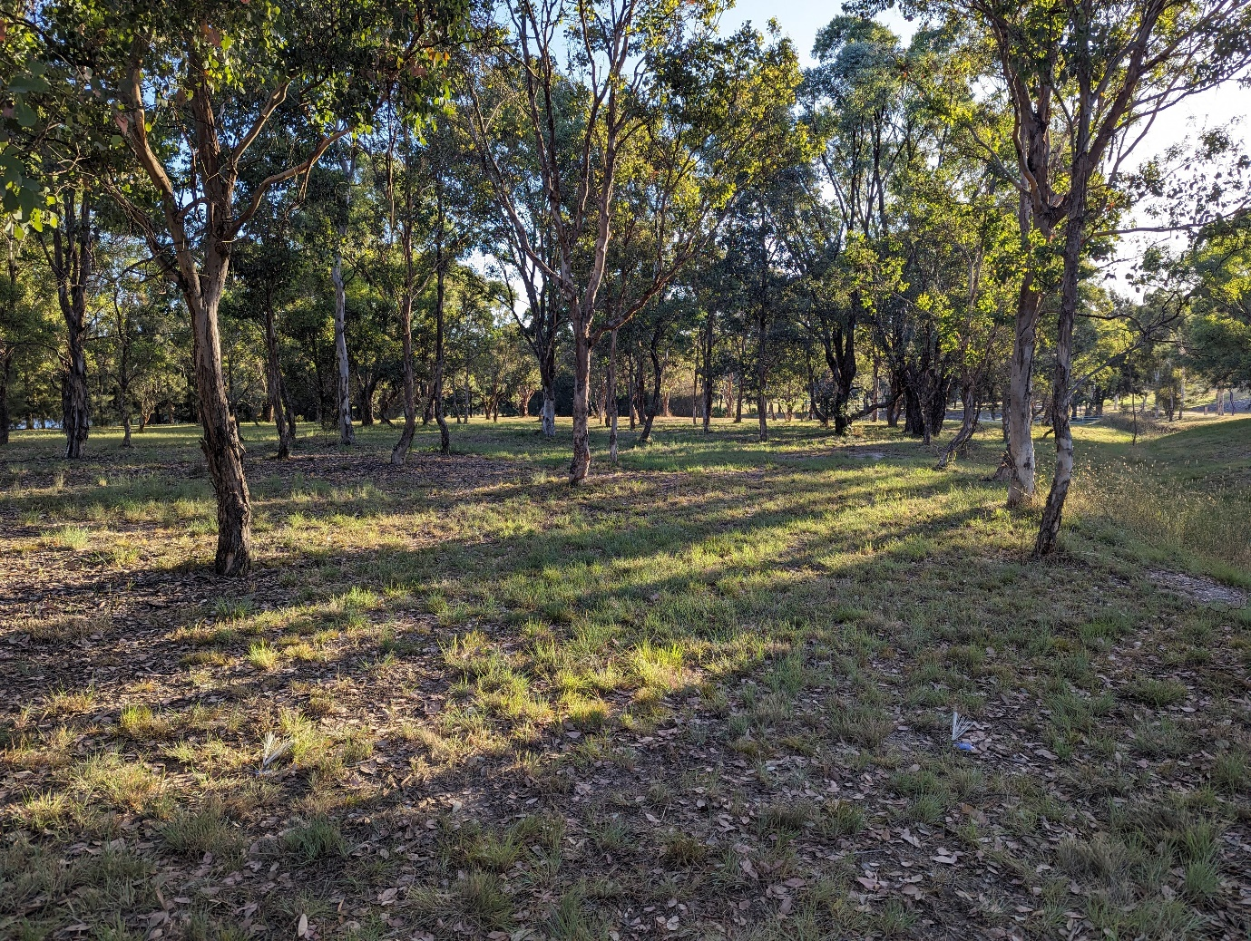

Hole 7 – Par 3 (123m)
Rules:
- Bollards deep of the pin play as out of bounds
- Black path and dirt path play as out of bounds
- Be mindful of players on Hole 10 this is a shared fairway
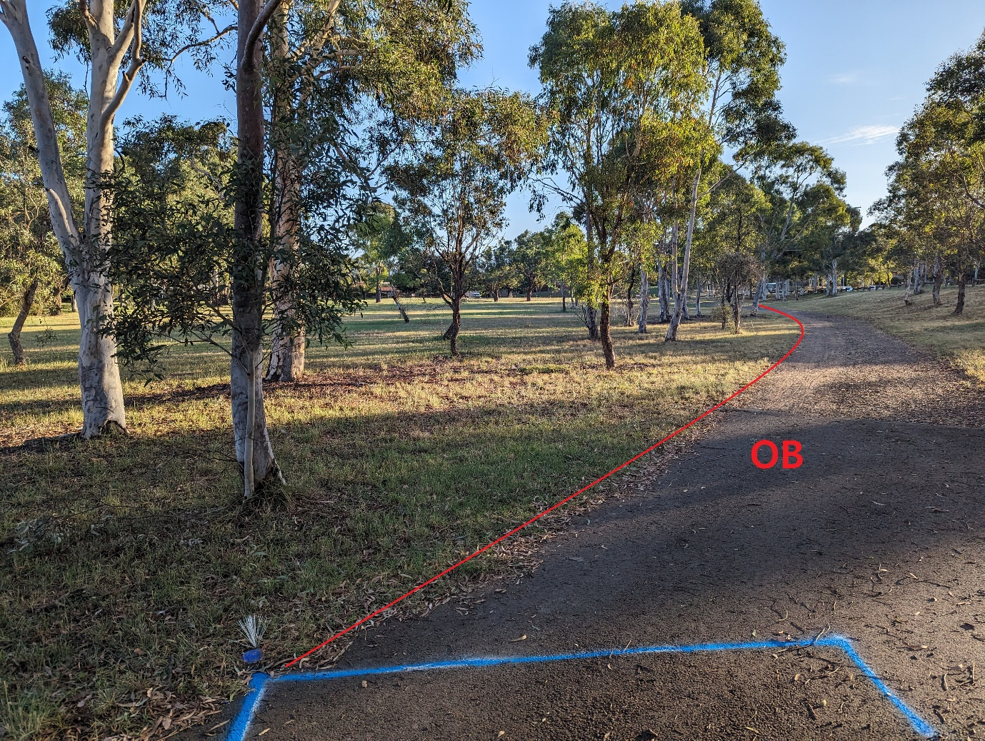

Hole 8 – Par 3 (96m)
Rules:
- Footpaths on the right play as out of bounds (but should not come into play)
- Mandatory right of the tree marked. Drop zone white markers next to tree.
- Be mindful of players on Hole 9
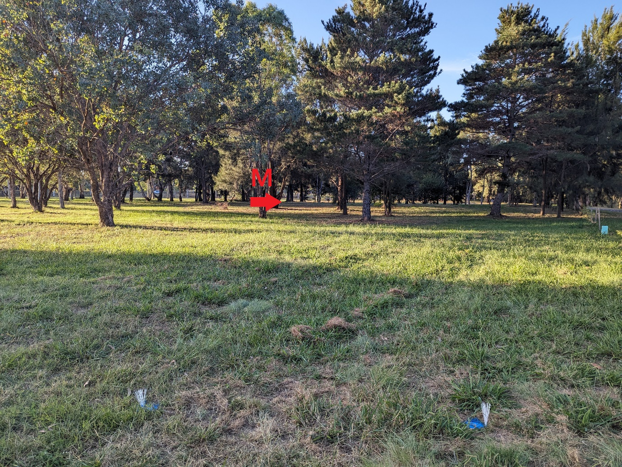
Hole 9 – Par 3 (89m)
Rules:
- Double mandatory. Drop zone marked just in front of the mandos by white markers.
- Be mindful of players on Hole 8
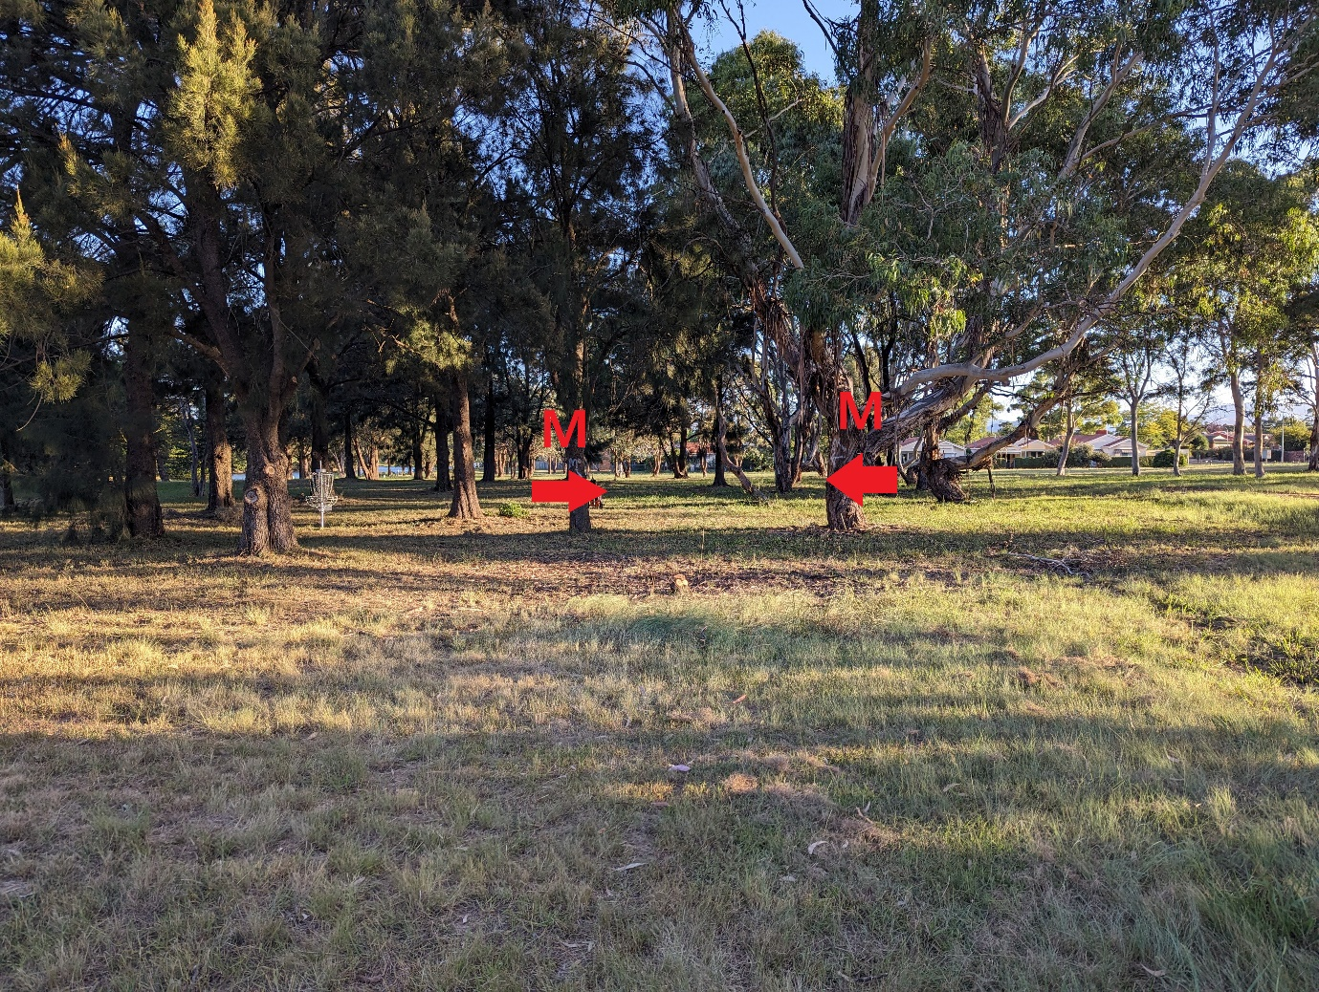
Hole 10 – Par 4 (156m)
Rules:
- Footpaths play as out of bounds
- 2 mandatories are on this hole:
  - 1st is mandatory right with a drop zone marked by white makers
  - 2nd is a mandatory left with a drop zone next to the left of the tree
- Be mindful of players on Hole 7 this is a shared fairway
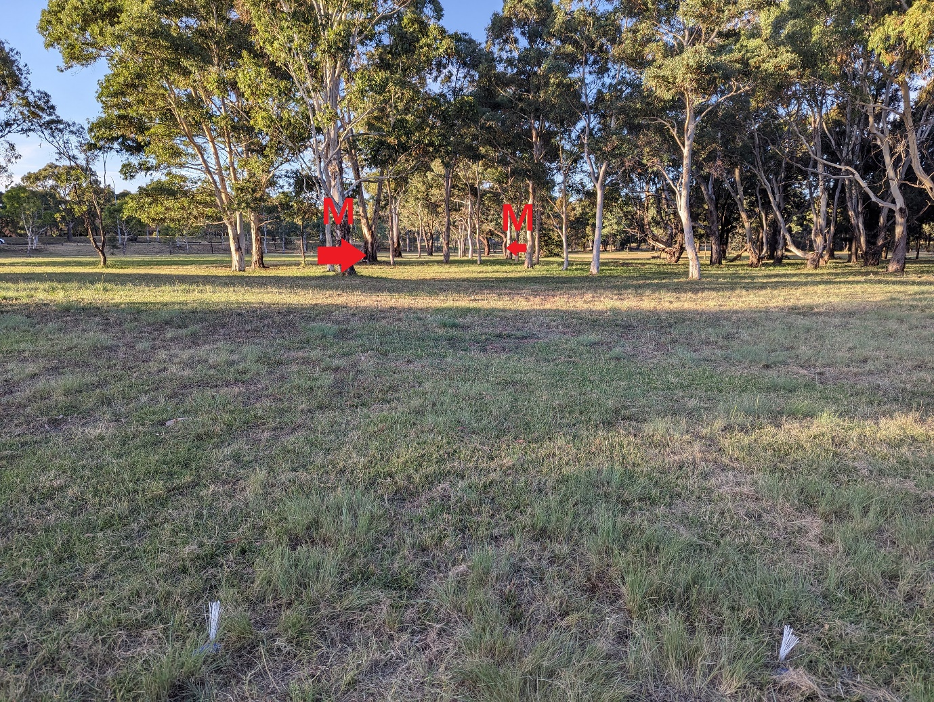
Hole 11 – Par 4 (186m)
Rules:
- Footpaths on the right play as out of bounds (but should not come into play)
- Bollards play as out of bounds
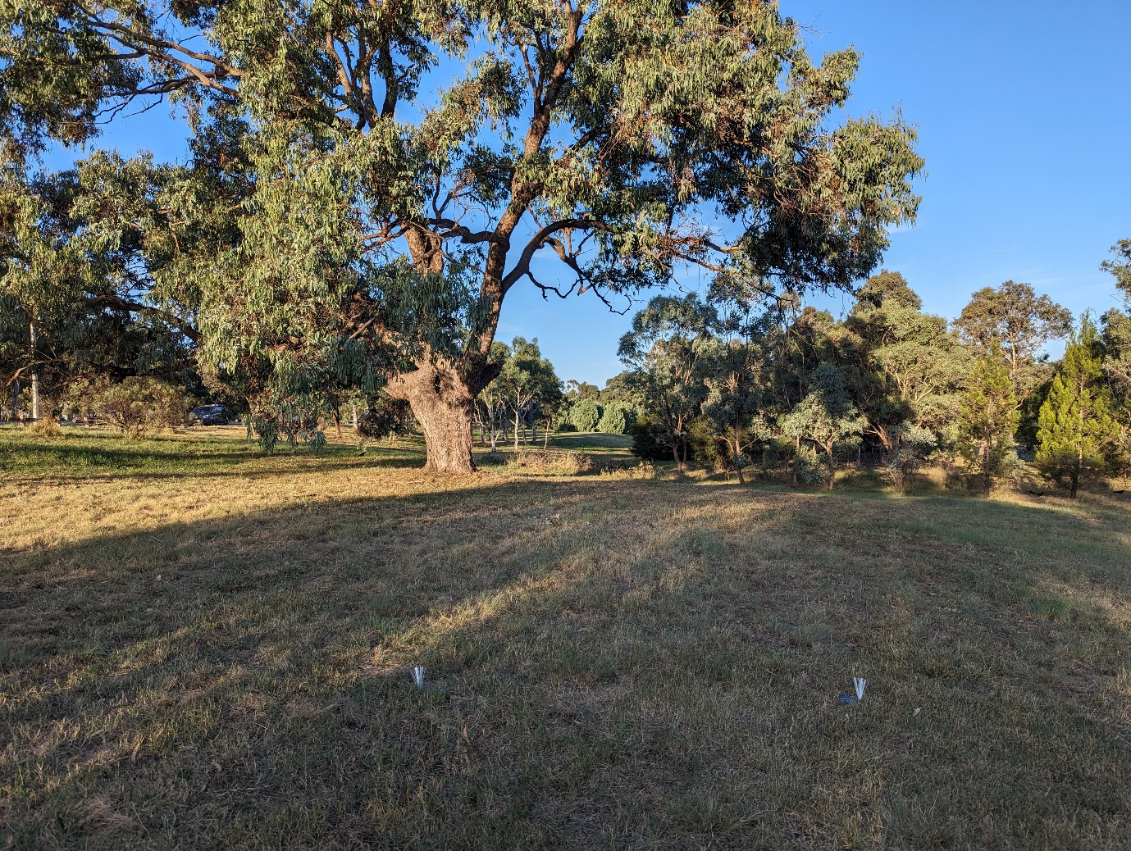

Hole 12 – Par 3 (83m)
Rules:
- Footpaths on the right play as out of bounds (but should not come into play)
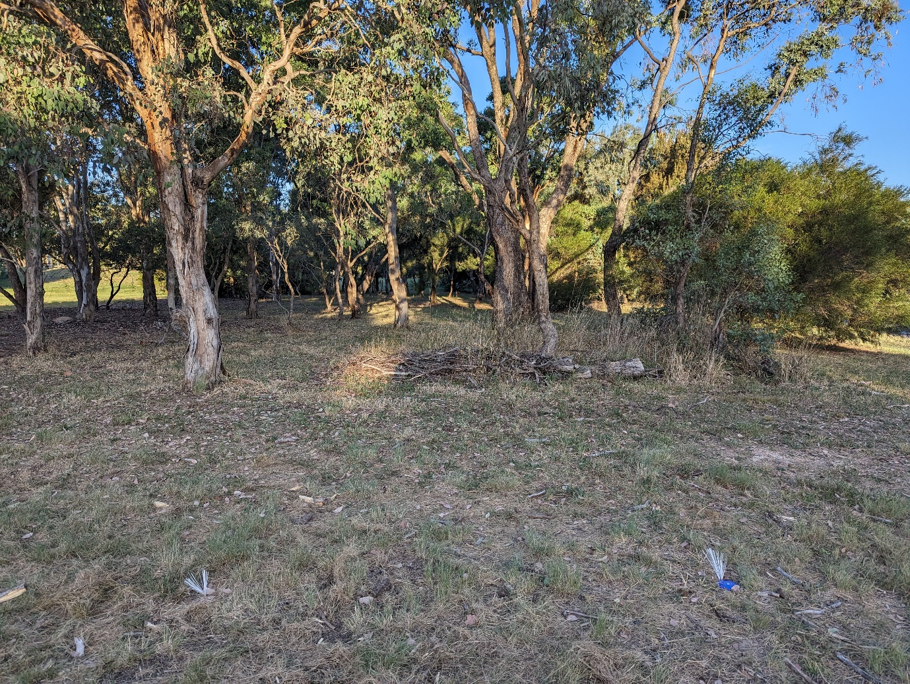
Hole 13 – Par 3 (95m)
Rules:
- Footpaths on the left play as out of bounds (but should not come into play)
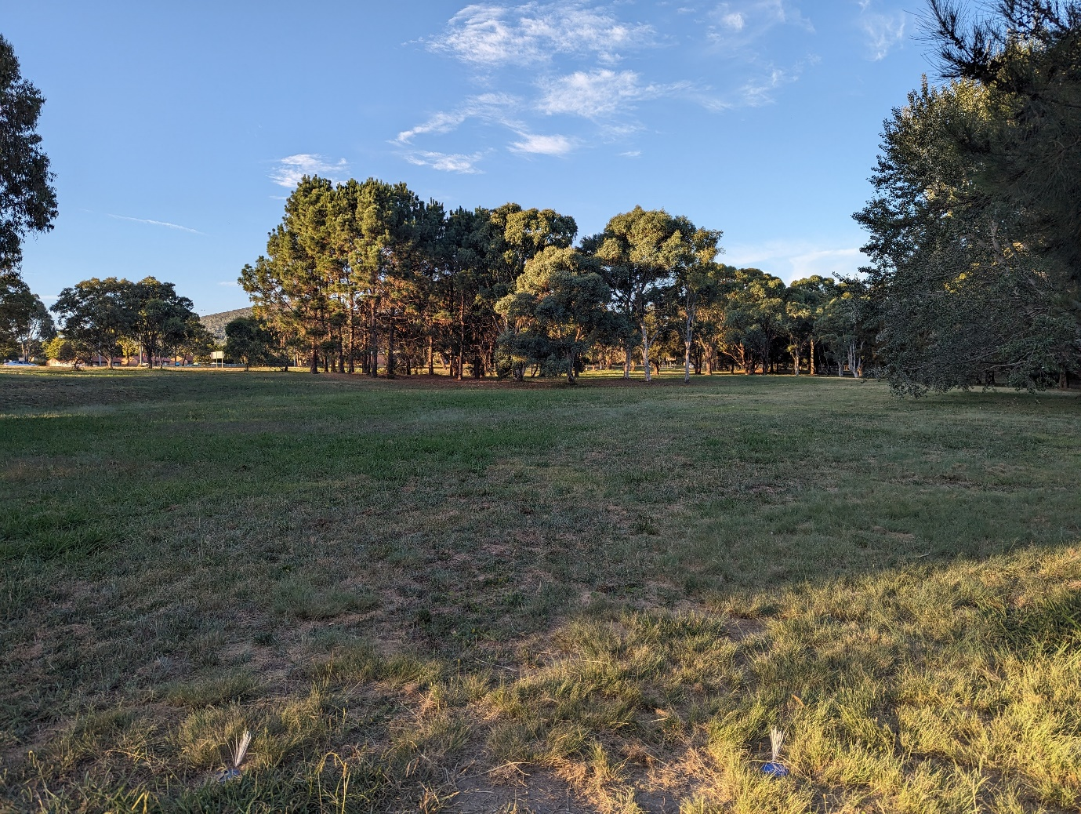

Hole 14 – Par 3 (90m)
Rules:
- Footpaths on the right play as out of bounds (but should not come into play)
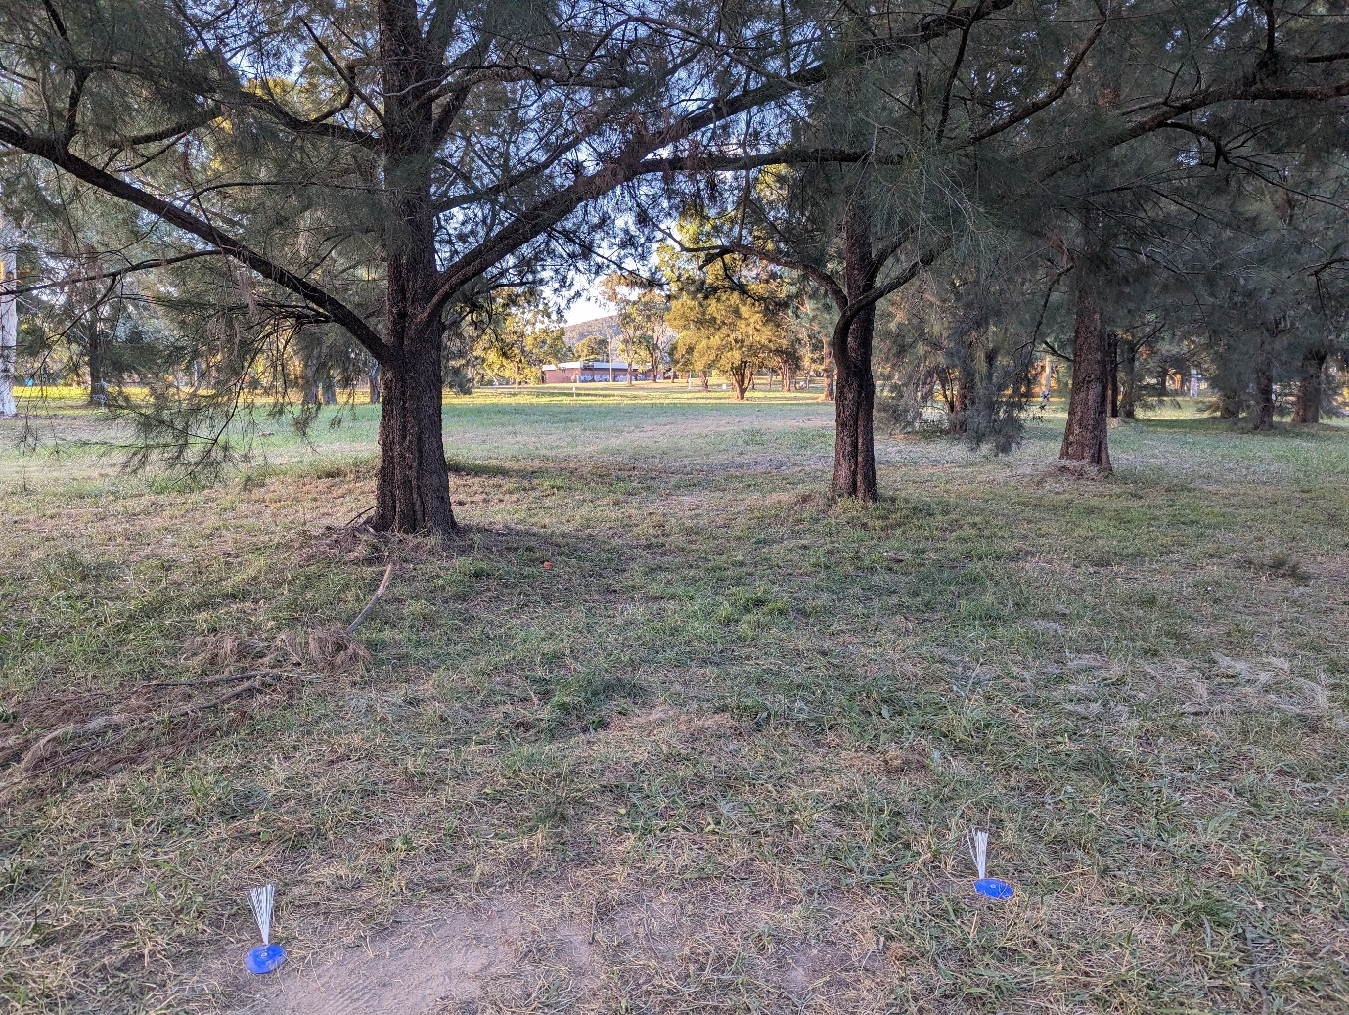

Hole 15 – Par 4 (138m)
Rules:
- Footpaths on the right play as out of bounds
- Stormwater drain plays as out of bounds
- Mandatory left of the tree next to the footpath. Drop zone is marked next to the left of post.
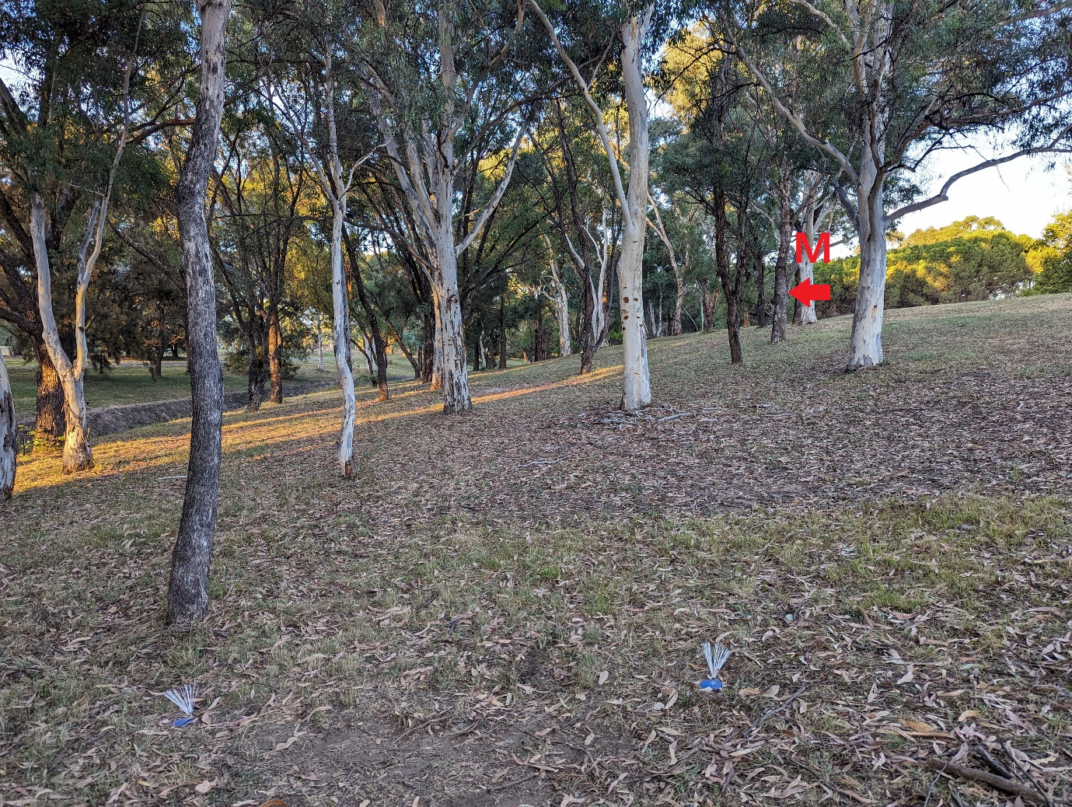

Hole 16 – Par 3 (99m)
Rules:
- Footpath on the left play as out of bounds
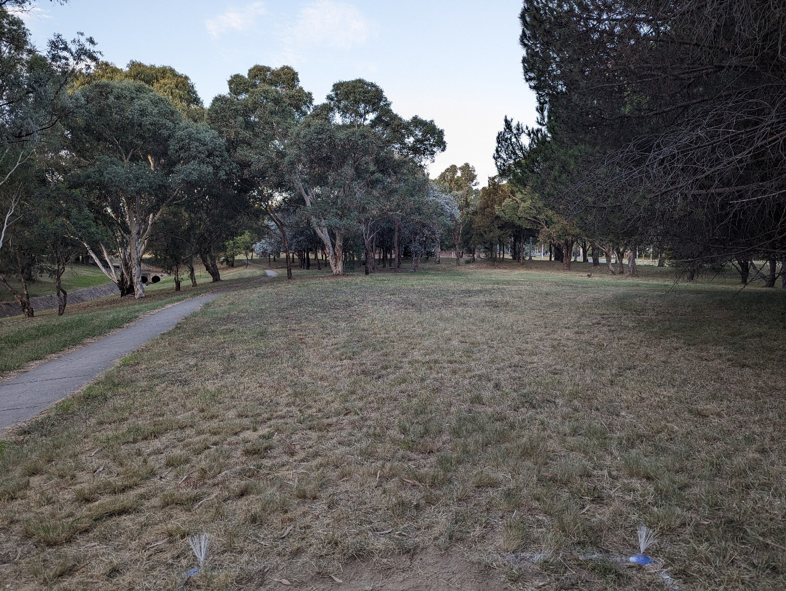
Hole 17 – Par 3 (90m)
Rules:
- Footpaths on the left play as out of bounds (but should not come into play)
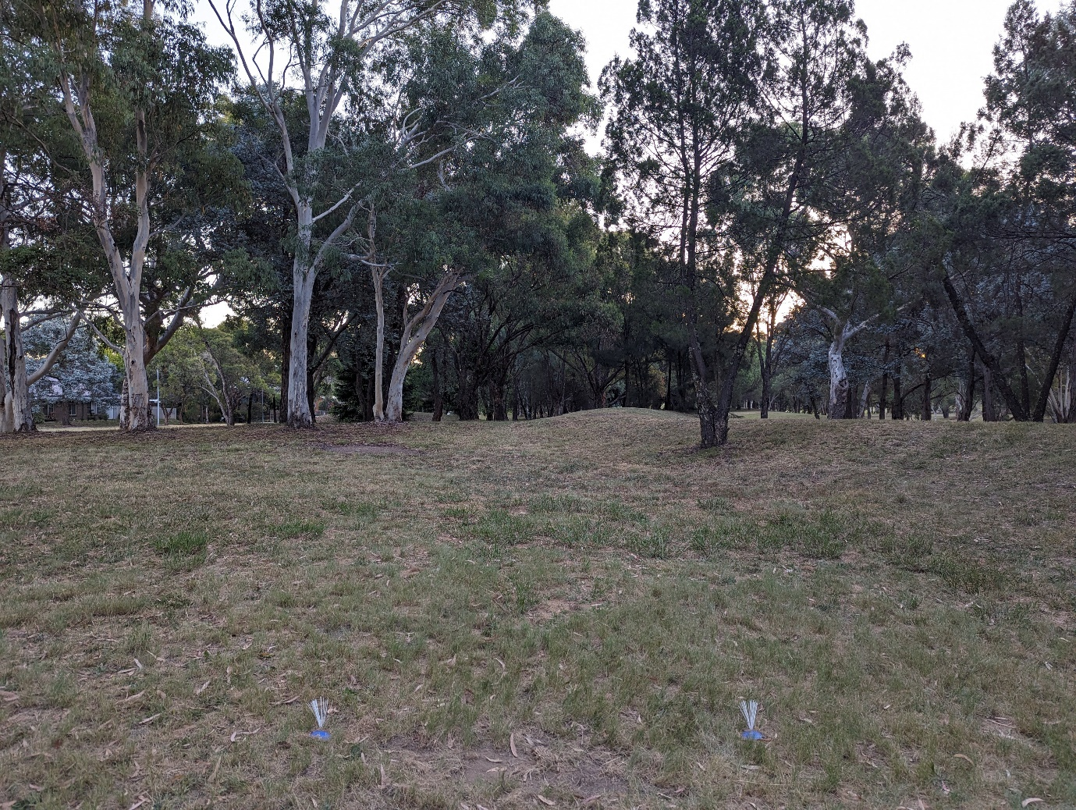

Hole 18 – Par 3 (176m)
Rules:
- Footpaths play as out of bounds
- Mandatory right of the power line post. Drop zone is to the right of the post.
